# UFCFTR-30-3/UFCF85-30-3

# Distribute & Enterprise Software Development

# Sprint Review Form

|  |  |
| --- | --- |
| Group: | 6 |
| Sprint: | 1 |
| Members: | Katie Hoult, Haroun Aiouadj, Shuaib Shahbaz, Lewis Clark, Grigore Nirca, Finlay Yates |

<<Burn-down Chart>>

We are using both Click Up features and Team Gantt to monitor our progress as a group. Katie created a Team Gantt link for the group where all members can simultaneously update the Gantt chart and eventually each user will have their own allocated tasks. For sprint 1, we did everything together and did not allocate tasks.

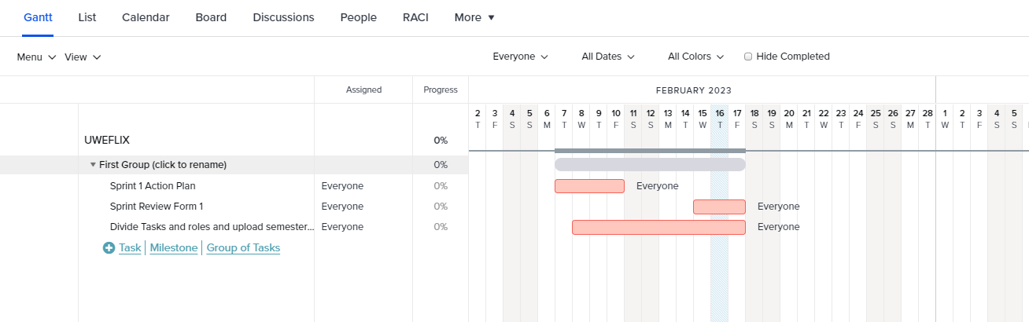

<<Backlog list>>

Below is the to-do list that was created via Click Up which all members of the group has access to and all changes made are live and this allows us all to work together coherently.

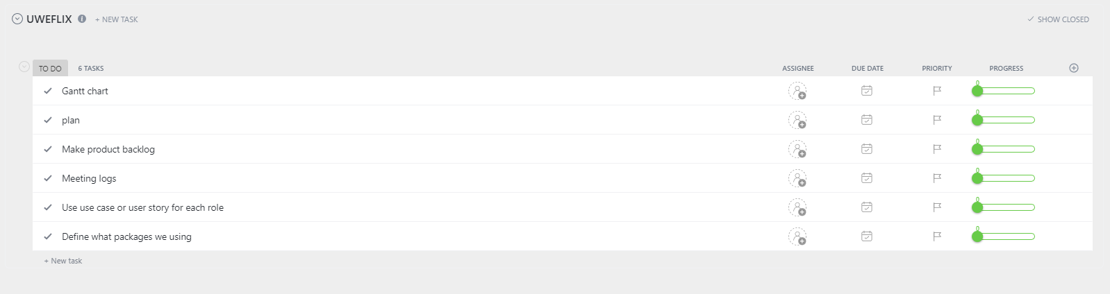

Figure 2, below, represents the early stages of our project planner with the risks labelled where we can view the progress we have made.

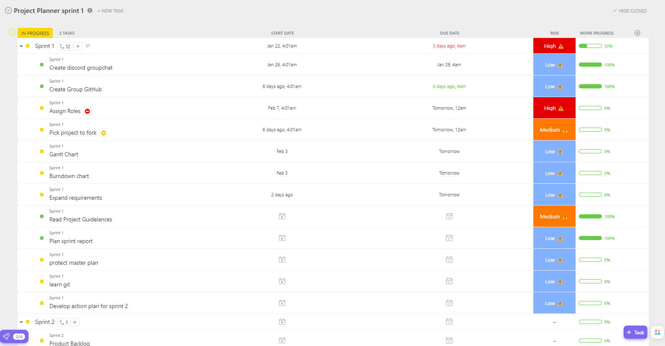

<<Communication Issues>>

During sprint 1 as a group we have found it hard to schedule meeting when everyone is available, apart from this we all have manage to introduce ourselves one way or another.

<<Reflections>>

To overcome the small communication issues as a group we have allocated a general manager to help catch people up being Katie. Haroun then created a ‘ClickUp’ board where all group members can see and add to a to-do list. Finally, in addition, Shuaib created a discord channel where we host our meeting calls and communicate regularly through messages or voice calls. This is a good practice we adopted as a group which enables all members to stay in touch and keep up to date with decisions made if they are unable to attend the voice call meetings we have arranged on a weekly basis, scheduled when the highest majority of members are available.

Finlay created a git hub for group members to upload parts of code as we thought this would be a good way to allow members to work together and to help one another with parts of code if needed.

<<Relevant Links>>

Click Up: <https://app.clickup.com/9005041800/v/l/6-900500447091-1>

Discord: <https://discord.com/channels/1071002642823790643/1071002643599728693>

Team Gantt: <https://app.teamgantt.com/projects/gantt?ids=3404017>

Git Hub: <https://github.com/fyates1/UWEFlix-Group-6>